**BOEING 787-8 SPECIFICATIONS**

Wing span = 60.1 m 🡪 con wingtips

Height = 17 m

Length = 56.7 m

Range = 13530 km

Wing Area = 325 m^2

Wing sweep back: 32.2 degrees

MTOW = 228,930 kg

MLW = 172·103 kg

MZFW = 161·103 kg

OEW = 119,950 kg

Fuel capacity = 126,206 l

Maximum: Mach = 0.9, v = 954 km/h

Cruise: Mach = 0.85, v = 903 km/h

Ceiling = 13,100 m

**CALCULATED PARAMETERS**

Wing span = 58 m 🡪 sin wingtips

y-coordinate section 3 = 20.8 m

y-coordinate section 2 = 10.6 m

y-coordinate section 1 = 3 m

Chord section 3 = 4.2 m

Chord section 2 = 7.15 m

Chord section 1 = 11.9 m

**PLATFORM**

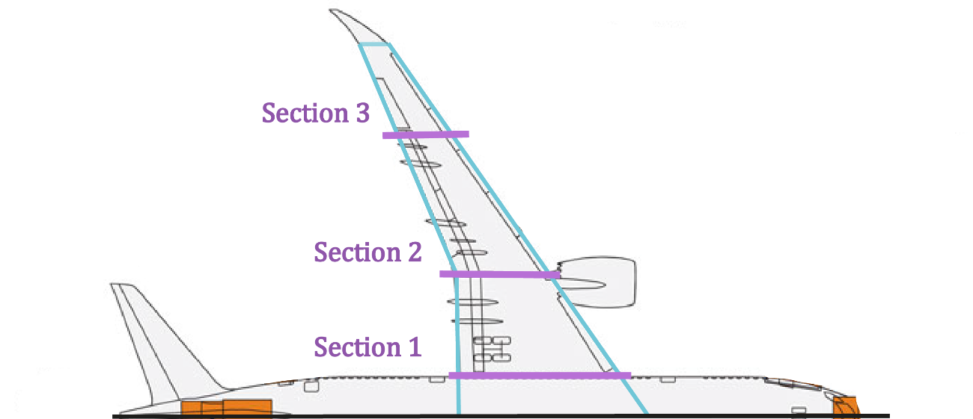

**MATERIALS**

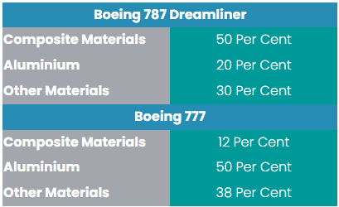

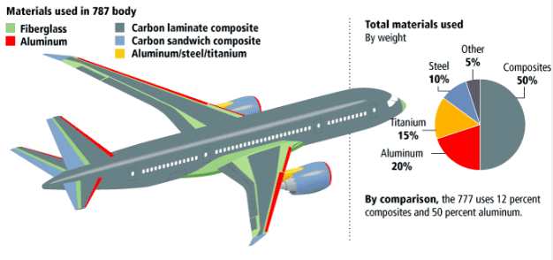

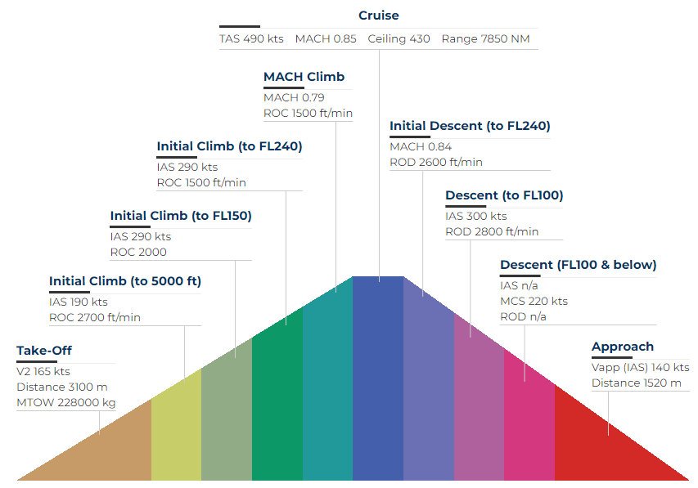

<https://www.boeing.com/commercial/787/>

<https://www.skybrary.aero/aircraft/b788>

<https://www.modernairliners.com/boeing-787#specs>

<https://www.norwegian.com/contentassets/833bf9fa7a654c1db6713032fae29da8/nor-2018-18---v02---09jul18---787-briefing.pdf>

<https://www.lissys.uk/samp1/index.html>